|  |  |
| --- | --- |
| **Logo_Baru-Rasmi_UUM_02** | STIW2044: Mobile Programming Semester 182School of Computing, CAS, UUM |
| Lab 1 | |
| 17/2/2019  Submission  24/2/2019 | |

**Java Class File**

**package** com.example.distanceconverter;  
  
**import** android.renderscript.Sampler;  
**import** android.support.v7.app.AppCompatActivity;  
**import** android.os.Bundle;  
**import** android.view.View;  
**import** android.widget.Button;  
**import** android.widget.EditText;  
**import** android.widget.Toast;  
  
**import** java.text.DecimalFormat;  
  
**public class** MainActivity **extends** AppCompatActivity {  
  
 EditText **km**,**m**,**miles**;  
 Button **clear**,**convert**;  
  
 *//2 decimal format* **private static** DecimalFormat *decimalFormat* = **new** DecimalFormat(**"#.##"**);  
  
  
 @Override  
 **protected void** onCreate(Bundle savedInstanceState) {  
 **super**.onCreate(savedInstanceState);  
 setContentView(R.layout.***activity\_main***);  
 **km** = findViewById(R.id.***km***);  
 **m** = findViewById(R.id.***m***);  
 **miles** = findViewById(R.id.***miles***);  
 **clear** = findViewById(R.id.***clear***);  
 **convert** = findViewById(R.id.***convert***);  
  
 *//function for convert button to operate* **convert**.setOnClickListener(**new** View.OnClickListener() {  
 @Override  
 **public void** onClick(View v) {  
 **final** String kilometre = **km**.getText().toString();  
 **final** String metre = **m**.getText().toString();  
 **final** String mile = **miles**.getText().toString();  
  
 **double** valueKM,valueMetre,valueMile;  
  
 *//to calculate km* **if** (metre.equals(**""**)&& mile.equals(**""**)){  
 valueKM = Double.*parseDouble*(kilometre);  
 valueMetre = valueKM \* 1000;  
 valueMile = valueKM \* 0.621371;  
  
 String totalValueMetre = *decimalFormat*.format(valueMetre);  
 String totalValueMile = *decimalFormat*.format(valueMile);  
  
 **m**.setText(totalValueMetre);  
 **miles**.setText(totalValueMile);  
 }  
  
 *//to calculate m* **else if** (kilometre.equals(**""**)&& mile.equals(**""**)){  
  
 valueMetre = Double.*parseDouble*(metre);  
 valueKM = valueMetre \* 0.001;  
 valueMile = valueMetre \* 0.000621371;  
  
 String totalValueMile = *decimalFormat*.format(valueMile);  
 String totalValueKM = *decimalFormat*.format(valueKM);  
  
 **km**.setText(totalValueKM);  
 **miles**.setText(totalValueMile);  
 }  
  
 *//to calculate miles* **else if** (kilometre.equals(**""**) && metre.equals(**""**)){  
  
 valueMile = Double.*parseDouble*(mile);  
 valueKM = valueMile \* 1.60934;  
 valueMetre = valueMile \* 1609.34;  
  
 String totalValueKM = *decimalFormat*.format(valueKM);  
 String totalValueMetre = *decimalFormat*.format(valueMetre);  
  
 **km**.setText(totalValueKM);  
 **m**.setText(totalValueMetre);  
 }  
  
 Toast.*makeText*(getApplicationContext(),**"Convertion Successful"**, Toast.***LENGTH\_LONG***).show();  
 }  
 });  
  
 *//clear button function* **clear**.setOnClickListener(**new** View.OnClickListener() {  
 @Override  
 **public void** onClick(View v) {  
 **km**.setText(**""**);  
 **m**.setText(**""**);  
 **miles**.setText(**""**);  
  
 Toast.*makeText*(getApplicationContext(),**"Cleared Successful"**, Toast.***LENGTH\_LONG***).show();  
 }  
 });  
  
  
 }  
}

**Activity \_Main.xml**

*<?***xml version="1.0" encoding="utf-8"***?>*<**ScrollView xmlns:android="http://schemas.android.com/apk/res/android"  
 xmlns:app="http://schemas.android.com/apk/res-auto"  
 xmlns:tools="http://schemas.android.com/tools"  
 android:layout\_width="match\_parent"  
 android:layout\_height="match\_parent"  
 android:layout\_gravity="center"  
 android:background="@android:color/background\_light"  
 tools:context=".MainActivity"**>  
  
 <**LinearLayout  
 android:layout\_width="match\_parent"  
 android:layout\_height="wrap\_content"  
 android:orientation="vertical"**>  
  
 <**TextView  
 android:id="@+id/textView"  
 android:layout\_width="match\_parent"  
 android:layout\_height="wrap\_content"  
 android:background="@android:color/background\_light"  
 android:gravity="center"  
 android:text="@string/DistanceUnitConverter"  
 android:textSize="36sp"  
 android:textStyle="bold"** />  
  
 <**LinearLayout  
 android:layout\_width="match\_parent"  
 android:layout\_height="match\_parent"  
 android:orientation="vertical"**>  
  
 <**TextView  
 android:id="@+id/textView1"  
 android:layout\_width="match\_parent"  
 android:layout\_height="wrap\_content"  
 android:layout\_gravity="center\_horizontal"  
 android:gravity="center\_horizontal"  
 android:text="@string/Kilometre"  
 android:textColor="@android:color/holo\_red\_light"  
 android:textSize="24sp"  
 android:textStyle="bold"** />  
  
 <**EditText  
 android:id="@+id/km"  
 android:layout\_width="match\_parent"  
 android:layout\_height="wrap\_content"  
 android:layout\_gravity="center\_horizontal"  
 android:ems="10"  
 android:gravity="center\_horizontal"  
 android:hint="@string/km"  
 android:inputType="textPersonName"** />  
 </**LinearLayout**>  
  
 <**LinearLayout  
 android:layout\_width="match\_parent"  
 android:layout\_height="match\_parent"  
 android:orientation="vertical"**>  
  
 <**TextView  
 android:id="@+id/textView2"  
 android:layout\_width="match\_parent"  
 android:layout\_height="wrap\_content"  
 android:layout\_gravity="center\_horizontal"  
 android:gravity="center\_horizontal"  
 android:text="@string/Metre"  
 android:textColor="@color/colorPrimary"  
 android:textSize="24sp"  
 android:textStyle="bold"** />  
  
 <**EditText  
 android:id="@+id/m"  
 android:layout\_width="match\_parent"  
 android:layout\_height="wrap\_content"  
 android:layout\_gravity="center\_horizontal"  
 android:ems="10"  
 android:gravity="center\_horizontal"  
 android:hint="@string/m"  
 android:inputType="textPersonName"** />  
 </**LinearLayout**>  
  
 <**LinearLayout  
 android:layout\_width="match\_parent"  
 android:layout\_height="match\_parent"  
 android:orientation="vertical"**>  
  
 <**TextView  
 android:id="@+id/textView3"  
 android:layout\_width="match\_parent"  
 android:layout\_height="wrap\_content"  
 android:layout\_gravity="center\_horizontal"  
 android:gravity="center\_horizontal"  
 android:text="@string/Miles"  
 android:textColor="@android:color/holo\_purple"  
 android:textSize="24sp"  
 android:textStyle="bold"** />  
  
 <**EditText  
 android:id="@+id/miles"  
 android:layout\_width="match\_parent"  
 android:layout\_height="wrap\_content"  
 android:layout\_gravity="center\_horizontal"  
 android:ems="10"  
 android:gravity="center\_horizontal"  
 android:hint="@string/miles"  
 android:inputType="textPersonName"** />  
 </**LinearLayout**>  
  
 <**LinearLayout  
 android:layout\_width="match\_parent"  
 android:layout\_height="match\_parent"  
 android:gravity="center\_horizontal"  
 android:orientation="horizontal"**>  
  
 <**Button  
 android:id="@+id/clear"  
 android:layout\_width="wrap\_content"  
 android:layout\_height="wrap\_content"  
 android:layout\_gravity="center\_horizontal"  
 android:layout\_weight="0.5"  
 android:background="@color/colorAccent"  
 android:text="@string/Clear"** />  
  
 <**Button  
 android:id="@+id/convert"  
 android:layout\_width="wrap\_content"  
 android:layout\_height="wrap\_content"  
 android:layout\_gravity="center\_horizontal"  
 android:layout\_weight="0.5"  
 android:background="?attr/colorError"  
 android:text="@string/Convert"** />  
 </**LinearLayout**>  
  
 <**TextView  
 android:id="@+id/textView4"  
 android:layout\_width="match\_parent"  
 android:layout\_height="wrap\_content"  
 android:gravity="left"  
 android:text="@GV3N"** />  
  
 </**LinearLayout**>  
</**ScrollView**>

**Blueprint**

**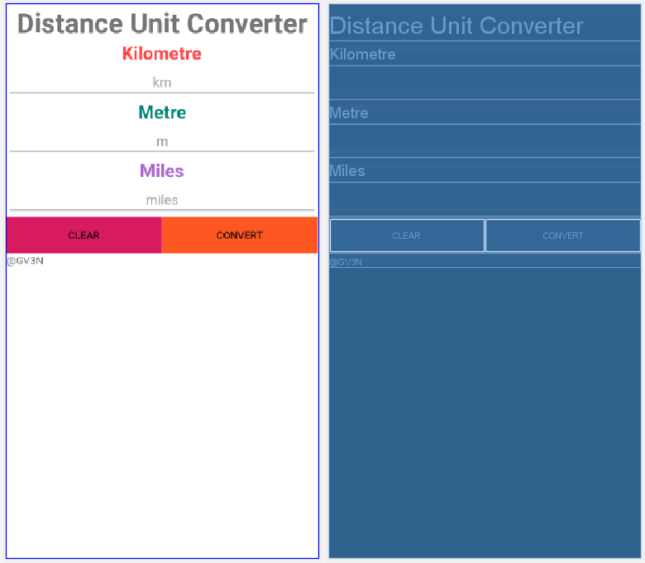**

**Screenshot of Input-Process-Output**

**